Title: Results from the detection of elder abuse through emergency care technicians (DETECT) tool study
Journal: TBD
Authors:

Brianna Burzynski
Department of Epidemiology, Human Genetics & Environmental Sciences

Morrigan Mahady
Department of Epidemiology, Human Genetics & Environmental Sciences
University of Texas School of Public Health
Dallas Campus
Dallas, TX 75390
Email: Morrigan.Mahady@uth.tmc.edu

Brad Cannell, PhD, MPH
Associate Professor
Department of Epidemiology, Human Genetics & Environmental Sciences
University of Texas School of Public Health
Dallas Campus
Dallas, TX 75390
Phone: 972-546-2941
Email: Michael.B.Cannell@uth.tmc.edu

Melvin Livingston, PhD
Research Associate Professor
Department of Behavioral Sciences and Health Education
Rollins School of Public Health
Emory University
Atlanta, GA 30322
Email: Melvin.Livingston@emory.edu

Jason Burnett, PhD
Associate Professor
Joan and Stanford Alexander Division of Geriatric and Palliative Medicine
McGovern Medical School
The University of Texas Health Science Center at Houston
Houston, TX 77030
Phone: 713-500-3845
Email: Jason.Burnett@uth.tmc.edu

…

Funding:
This project was supported by Award No. 2014-MU-CX-0102, awarded by the National Institute of Justice, Office of Justice Programs, U.S. Department of Justice. The opinions, findings, and conclusions or recommendations expressed in this publication are those of the author(s) and do not necessarily reflect those of the Department of Justice.
This research was also supported by the National Institute on Aging of the National Institutes of Health under Award Number R01AG059993. The content is solely the responsibility of the authors and does not necessarily represent the official views of the National Institutes of Health.

Conflicts of interest:
The authors have nothing to disclose.

Word Count: 0 / TBD
JAMA: 3,000 words or less
JEAN: 12,000 words or less
BMJ: 3,000-4,000 recommended, no hard cap
Tables: TBD
Figures: TBD

Author Contribution Statement:

Abstract (0 / 150) Between 1-3 sentences, include commentary as a keyword

Objective

Methods

Results

Conclusions

Introduction
Elder mistreatment (EM) occurs when an older adult is harmed or at risk of harm due to any act or failure to act, regardless of intent, made by a caregiver or other adult in a relationship that contains an expectation of trust^{1–3}. There are five major types of elder mistreatment – physical, sexual, emotional or psychological abuse, neglect, and financial exploitation. These categories are further expanded and defined by Texas Adult Protective Services (APS): sexual abuse, emotional abuse, physical abuse, physical neglect, medical neglect, mental health neglect, and financial exploitation^{1–5}. These types of EM are known to occur jointly, which results in polyvictimization and difficulty classifying the specific types of mistreatments that victims may experience^{2,4,6}.
Conservative estimates indicate that 11% of cognitively intact older adults^{7,8} and 30-75% of older adults with Alzheimer's Disease or Related Dementias (ADRD)^{7,9–13} in the United States experience EM each year. It is estimated that there are 23.5 unreported incidents for each reported incident among cognitively intact adults¹⁴, but those with ADRD are regarded as both more likely to experience EM and less likely to report EM to authorities^{2,13,15,16}. EM is also associated with many negative outcomes including loss of property and security^{2,4,17}, physical injury^{12,18}, hospitalizations^{12,19}, emergency room visits¹², psychological distress^{12,20–23}, poor quality of life^{12,24}, morbidity^{12,25}, and early mortality^{12,25,26}. In addition to having a greater risk of victimization, older adults with ADRDs experience more severe negative consequences of EM^{4,13}. Caregiver financial exploitation alone is estimated to be responsible for $6.67 billion dollars of annual losses¹⁷, and the direct medical costs to treat injuries from physical abuse are estimated to be $5.3 billion dollars annually²⁷.
Early identification and intervention EM cases is crucial to prevent further harms. Emergency medical technicians and paramedics (medics) are medical providers uniquely placed to assist in this effort. Older adults utilize emergency medical services more than four times as often as younger adults²⁸. Through unique access into the homes of older adults, medics are able to make observations of the older adult’s living environment that are not possible in the typical outpatient clinic^{29,30}. However, current screening tools to assist in the detection of EM have limited suitability for medics, particularly with older adults with ADRDs or other capacity limitations: methods that require specialized training, lengthy questioning, cooperation from a caregiver, or the mental capacity and candid cooperation of the older adult are typically deemed inappropriate in an emergency response setting^{10,25,29,31–41}.

Background of the DETECT Screening Tool
Previously, our team developed and pilot tested an EM screening tool: Detection of Elder abuse Through Emergency Care Technicians (DETECT)^{29,42}. It was designed to help medics identify potential EM through their encounters with older adults living in the community during an emergency using only observations of the older adult’s physical health and social contexts.
The DETECT screening tool was developed and pilot tested in partnership with Texas APS and MedStar Mobile Healthcare (MedStar) - one of the largest mobile healthcare providers in North Texas serving 436 square miles of Fort Worth and 14 surrounding cities in Johnson, Tarrant, and Dallas counties in Texas, with a population of over 1 million residents⁴³. The original 5-week pilot test of a 26-item DETECT screening tool resulted in a 226% increase in reports to APS recorded by MedStar’s Legal Compliance department, with 16.8% of screenings positive⁴². Three-year evaluation found a risk ratio of 3.03 (95% CI 2.06-4.46) for medic APS reporting of EM associated with using the DETECT screening tool, without a corresponding increase of the proportion of false positives reported to APS⁴⁴. After review by an expert panel of researchers, emergency medicine administrators, and medics, the DETECT tool was revised to 14 items and an optional item for medics to record intent to report and an APS report number were added.

Study Aims
The goal of the DETECT project was to refine the DETECT tool and validate its effectiveness in assisting medics in identifying potential EM among community-dwelling older adults. The full 5-year study sought to determine: (1) how often, if ever, are each of the items in the DETECT screening tool actually observed and recorded by medics in the field, (2) how often, if ever, does intent to report potential EM as recorded in the DETECT screening tool match recorded reporting from APS, (3) and how often, if ever, does a positive DETECT screening indicate conditions which present at least one valid allegation of EM in APS investigation?

Methods

Study setting
The 14 item DETECT screening tool was available to MedStar medics in the field between July 1, 2019 and May 31, 2023. The integration of the 14 item DETECT screening tool within the electronic Patient Care Record (ePCR) used by medics in the field was continued from our previous 5-week pilot study of the 26 item DETECT screening tool⁴². An eligible 911 response was defined as a call for any patient 65 years of age or older who resided within the community (e.g., private home, unlicensed board and care home, etc.), with the encounter located at the patient’s primary residence. Other types of residences, such as skilled nursing facilities, were excluded because reports of EM in these settings are not typically investigated by APS in Texas⁴⁵. Older adults that participated in our study lived within MedStar’s service area, which included Fort Worth, Texas and 14 surrounding communities⁴³. This represented approximately 990,000 older adults⁴⁶.

Table 1: Study population
 | Encounter Level  (N = 92,144) | Subject Level  (N = 41,952)
Number of Responses  Median (IQR, Range) |  | 1 (IQR 1-2, Range 1-95)
Age  Median (IQR, Range) | 75  (IQR 69 - 82,  Range 51 - 120) | 75  (IQR 69.67 - 83,  Range 51 - 120)
Sex
N (%)
Male | 37,315 (40.50%) | 17,718 (42.23%)
Female | 54,655 (59.31%) | 24,155 (57.58%)
Unable to Assess | 95 (0.10%) | 30 (0.07%)
Missing (NA) | 79 (0.09%) | 49 (0.12%)
Race
N (%)
White | 54,065 (58.67%) | 25,809 (61.52%)
Black or African American | 24,457 (26.54%) | 9,003 (21.46%)
Asian | 1,087 (1.18%) | 681 (1.62%)
Native Hawaiian or Other Pacific Islander | 69 (0.07%) | 50 (0.12%)
American Indian or Alaska Native | 47 (0.05%) | 27 (0.06%)
Middle Eastern or North African | 10 (0.01%) | 8 (0.02%)
Other Race | 1,309 (1.42%) | 725 (1.73%)
Multiracial | 138 (0.15%) | 146 (0.35%)
Missing (NA) | 10,962 (11.90%) | 5,503 (13.12%)
Ethnicity
N (%)
Hispanic or Latino | 10,683 (11.59%) | 5,565 (13.27%)
Not Hispanic or Latino | 81,019 (87.93%) | 36,193 (86.27%)
Missing (NA) | 442 (0.48%) | 194 (0.46%)
Screening Performed  N (%) | 92, 086 (99.94%) | 41,912 (99.90%)
Positive (1+ “Yes” response) | 3,681 (0.04%) | 2,772 (6.61%)
Negative (no “yes” response) | 88,405 (96.00%) | 39,140 (93.39%)
DETECT Tool Recorded Intent to Report  N (%) | 1,298 (1.41%) | 1,007 (2.40%)

Medic Screening and Reporting Procedures
Medic screening protocols, training, and operating procedures regarding the DETECT screening tool, were continued from our previous 5-week pilot study⁴². This included universal screening through validation rules that made it difficult, but not impossible, to close/submit an ePCR report without completion of the DETECT screening tool. MedStar’s standard operating procedures relating to dispatching calls for service and the provision of medical treatment were unchanged by the DETECT screening tool.
If the call for service was eligible, the medic would gain access to the DETECT tool in the ePCR and receive a prompt to complete the screening tool. Completion of the screening was made mandatory by the assignment of a point-value, which contributed towards the minimum required value required to close out or submit an ePCR report. There were no default values presented for any DETECT tool items. A response of “yes” to one or more screening items was considered a positive screening, which generated a prompt encouraging medics to report the positive screening to APS per Texas reporting mandates⁴⁷. Medics were encouraged to indicate if they made a report to APS and record the APS confirmation number in the DETECT screening tool.
The DETECT tool was created to assist medics in utilizing their professional judgement to determine if there was potential elder mistreatment occurring, and if APS should be contacted for further investigation and assistance. It was not designed to definitively determine the presence of elder mistreatment, nor was it designed to override or replace professional judgement. As such, it is important to note that a positive DETECT screening indicated potential conditions of elder mistreatment, rather than a confirmed occurrence of elder mistreatment.

Data sources and measurement
We combined data from two different sources to investigate our study aims:
- MedStar ePCR records. MedStar provided data on all potentially eligible responses during the study period, including responses to the DETECT screening tool items (N = 92,144; 41,952 Subjects). Only a single record for each EMS response was utilized for analysis; the most complete record for a single EMS response was selected, which was universally the record created by the primary EMS unit of any multiple-unit response. Data extracted from the electronic patient care record (ePCR) was automatically uploaded to a secure FTP site on a scheduled basis. Study staff downloaded this data onto a secured drive and uploaded it to FileMaker Pro, which performed automated pre-processing to facilitate randomization and recruitment for follow-up interviews. These records were used to investigate the frequency and patterns of DETECT screening tool use in the field.
- Texas Adult Protective Services investigation records. We received data regarding all APS intakes and investigations that were open during the study period (N = 568,616; 370,825 Subjects). These records were used to investigate associations with APS-determined outcomes.
A unique subject-level identifier was created in these records utilizing probabilistic fuzzy-matching with the R package fastLink⁴⁸. Matching was performed within each set, followed by between-set matching. Matching utilized the patient’s name, date of birth, and street address. Within-set matching for MedStar records additionally included sex, which was absent in the APS records. Pairs within a posterior probability range of 0.54-0.70 received additional verification of subject identifier assignments for the MedStar within-set matching. Pairs with posterior probabilities of 0.20-0.70 and 0.45-0.90 received similar verification in the APS within-set and between-set matching, respectively. There were 4,654 subjects present in both the MedStar response and APS records across 19,733 EMS responses.
MedStar response and APS records were linked for analysis. APS Investigations were linked to MedStar responses via temporal linkage, with a temporal link defined as an open APS investigation within 30 days before or after the MedStar response for the same subject. When multiple APS Investigations were linked to a single MedStar response, dispositions were aggregated to reflect a status of “Valid” (at least one valid determination of EM), “Invalid” (at least one invalid determination of EM)”, “Unable to Determine” (at least one “unable to determine,” no valid or invalid determinations of EM), or “Other (Not Investigated)” (at least one “other,” no other determination types). APS Intakes were linked to MedStar responses via temporal linkage, with a temporal link defined as an APS intake within the 72-hour period following the MedStar response for the same subject. Reporter types of “Health Care Providers/Staff -- EMS/EMT” were considered to be explicitly EMS reporters, while the reporter types of "Health Care Providers/Staff" or "Other Providers" were considered to possibly refer to an EMS reporter.

Analytic Methods
All analyses were conducted with R version 4.4.1 ("Race for Your Life")⁴⁹ and related packages. Plots were created using the ggplot2⁵⁰ and patchwork⁵¹ R packages.
For bivariate associations with our categorical outcomes, we utilized student t-test of means or Wilcoxon Rank-Sum testing for continuous predictors and Chi-square or Fisher’s Exact testing for independence for categorical predictors. Agreement was calculated with Cohen’s Kappa.

Subject demographics
We assessed the race, ethnicity, and sex composition of our study sample against the US 2020 Census data for Fort Worth⁴⁶ to assess the repetitiveness of our sample against the background population. We assessed the bivariate associations between our demographic variables and DETECT screening performance, DETECT tool response patterns, DETECT screening result, the presence of a matched APS Intake, and the presence of an APS determination of at least one valid allegation of EM for an investigation open within 30 days of the screening.

Screening tool use
To evaluate the use of the DETECT screening tool, we calculated the proportion of eligible older adults screened. We also calculated the number and proportion of positive DETECT screenings, DETECT tool recorded indicators of intent to place an APS report, and DETECT screenings with a matching record in the APS investigations data. Agreement was calculated between DETECT-recorded intent to report and the presence of a matching APS report.

Screening item response patterns
We calculated the response patterns of all 14 DETECT screening items. These items were designed to address elder mistreatment indicators frequently encountered by medics across 8 domains²⁹. Each item allowed the response options of “Yes,” “No,” “Unable to Assess,” and “N/A” (Not Applicable). We calculated the number and percent of screenings in which each potential response was observed for each screening item, and the number and percent of screenings in which a “Yes” response for a given item was the only “Yes” response on the screening. A comparative analysis of response patterns against our original 5-week pilot test was performed with Chi-Square test for independence.

Validation
Agreement was calculated to determine the concordance between positive DETECT screening and at least one valid determination of EM in temporally linked APS Investigations. Subjects absent from the APS data were considered to be negative for APS determination status. Analyses were repeated to determine the sensitivity to the omission of subjects absent from the APS data and our method of APS Investigation linkage.
The Committee for the Protection of Human Subjects at the University of Texas Health Science Center approved this project. Complete information regarding the definitions of terms used in APS investigations, analytic methods, additional results, and statistical programming code are available at https://github.com/brad-cannell/detect_fu_interviews_public.

Results

Procedural feasibility
During the study, MedStar medics responded to 92,114 eligible 911 calls for adults aged 65 and older at their residence. Screening completion rates were 100% after the second month of the study, resulting in 92,086 DETECT Screenings (99.98%).

Fidelity to screening and reporting frequency
Figure 1 illustrates the steps involved in the screening and reporting procedures used by MedStar medics during the study. Only 3,681 of the completed DETECT screenings (4.00%) were positive (i.e. a medic selected a “Yes” response to at least one screening item). Of these, only 1,285 (34.91%) indicated positive intent to report, with 540 (42.02%) matched to an APS Intake with an EMS reporter. Of note, 13 (0.01%) of the 88,405 negative DETECT screenings included a positive intent to report, with 2 (15.39%) matched to an APS Intake with an EMS reporter.

Figure 1: A flow diagram illustrating the DETECT study screening and reporting procedures
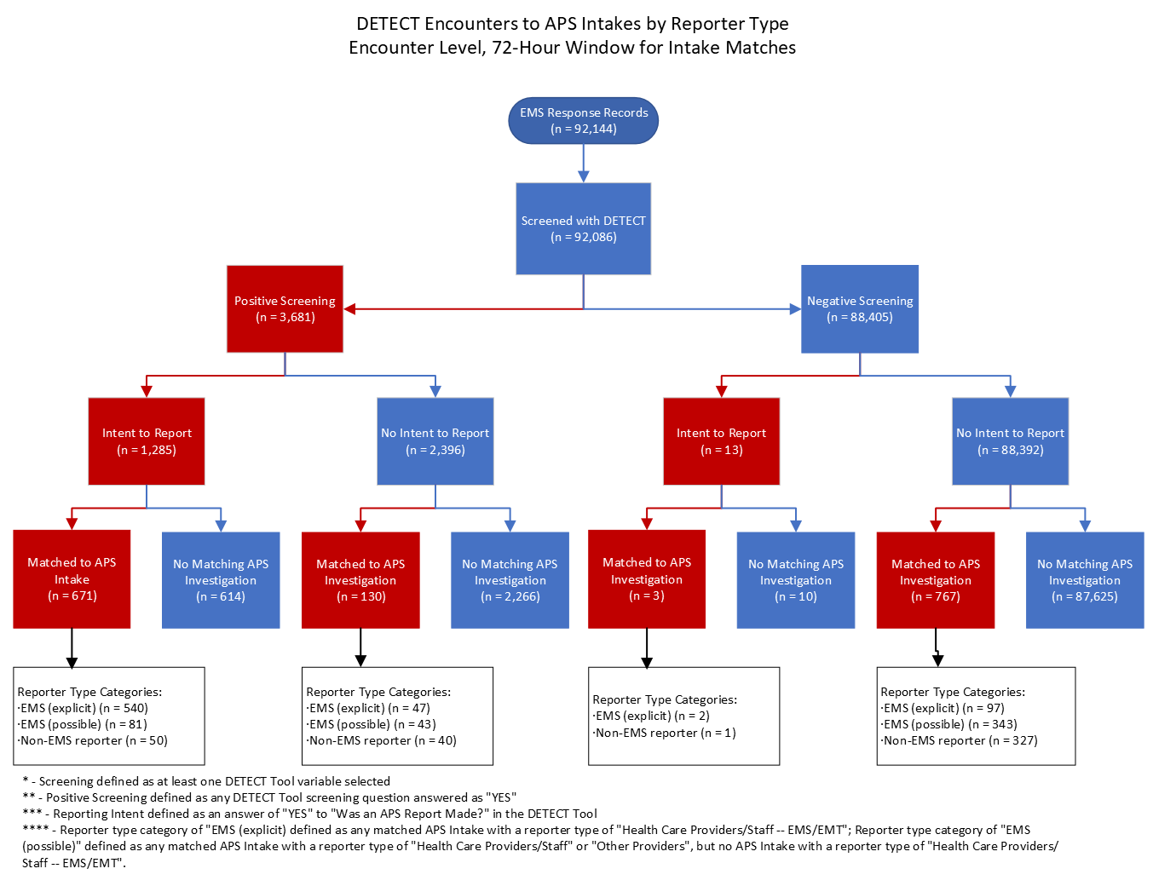

Screening item response patterns
Complete details about the response patterns for each individual screening item are given in Table 1. The four caregiver items (items 11-14) were the only items that were not routinely completed at every screening, with an average completion rate of 68.36%. “Yes” responses were selected for the individual screening items between 306 and 1,671 times, with an average frequency of 1.04%. The item with the highest percentage of “Yes” responses (1.81%) was item number 2 — “Inside of the home is in extreme disarray or there is hoarding”. The item with the lowest percentage of “Yes” responses (0.42%) was item number 9 — “Does the patient or older adult appear to be hoarding or saving old medications?”

Table 2: Response patterns for each of the 14 DETECT screening items.
Screening Item | Completed | Yes | No² | Unable to Assess (UTA) ² | Yes – Only Yes
 | N (%) | N (%) | N (%) | N (%) | N (%)
Unusual odor (e.g., urine, feces) | 92,086 (100.00%) | 1,658 (1.80%) | 85,986 (93.38%) | 4,442 (4.82%) | 255 (15.38%)
Inside of the home is in extreme disarray or there is hoarding | 92,085 (100.00%) | 1,671 (1.81%) | 81,375 (88.37%) | 9,039 (9.82%) | 250 (14.96%)
Living environment poses a health or safety concern (e.g., fire hazard, insect or rodent infestation, or urine or feces present) | 92,086 (100.00%) | 1,613 (1.75%) | 80,937 (87.89%) | 9,536 (10.36%) | 94 (5.83%)
Is the patient or older adult isolated in the home? | 92,086 (100.00%) | 776 (0.84%) | 91,310 (99.16%) | 0 (0%) | 45 (5.80%)
Does the patient or older adult have poor personal hygiene (including soiled in urine or feces)? | 92,086 (100.00%) | 1,519 (1.65%) | 90,567 (98.35%) | 0 (0%) | 69 (4.54%)
Is the patient or older adult inadequately clothed or wearing dirty, torn, or soiled clothing? | 92,085 (100.00%) | 1,266 (1.37%) | 90,819 (98.63%) | 0 (0%) | 52 (4.11%)
Does the patient or older adult have unmet needs for assistance with eating, toileting, transferring, dressing, or bathing? | 92,086 (100.00%) | 1,243 (1.35%) | 90,843 (98.65%) | 0 (0%) | 41 (3.30%)
Does the patient or older adult appear depressed, anxious, or emotionally distressed for reasons other than their immediate medical condition? | 92,086 (100.00%) | 673 (0.73%) | 91,413 (99.27%) | 0 (0%) | 95 (14.12%)
Does the patient or older adult appear to be hoarding or saving old medications? | 92,086 (100.00%) | 390 (0.42%) | 72,724 (78.97%) | 18,972 (20.60%) | 44 (11.28%)
Does the patient or older adult have difficulties taking their prescribed medications as directed? | 92,086 (100.00%) | 1,011 (1.10%) | 91,075 (98.90%) | 0 (0%) | 98 (9.69%)
If caregiver is present, they appear to lack knowledge of the patient or older adult’s medical needs | 62,211 (67.56%) | 538 (0.86%) | 61,673 (99.14%) | 0 (0%) | 66 (12.27%)
If caregiver is present, they appear unengaged and inattentive in caring for the patient or older adult | 63,197 (68.63%) | 333 (0.53%) | 62,864 (99.47%) | 0 (0%) | 18 (5.41%)
If caregiver is present, they appear frustrated, tired, angry, or burdened by the patient or older adult | 63,185 (68.62%) | 397 (0.63%) | 62,788 (99.37%) | 0 (0%) | 56 (14.11%)
If caregiver is present, they appear overly concerned (e.g., anxious, hovering) | 63,219 (68.65%) | 306 (0.48%) | 62,913 (99.52%) | 0 (0%) | 53 (17.32%)

Medic use of the “APS Report Number” field as a comment box
MedStar medics periodically utilized the “APS Report Number” field of the DETECT tool to record comments (N = 236, 0.26% of screenings). While many comments involved recording the name and ID number of the APS staff member they spoke to for their intake (N = 58, 24.58% of comments), medics also included comments reporting their belief that APS was already aware of the situation (N = 105, 44.49% of comments), that APS was either on scene or had called EMS (N = 53, 22.03% of comments), that another party—most frequently hospital staff, police, or fire department personnel—would make an APS report (N = 17, 7.20% of comments), or a belief that the situation did not require further intervention (N = 13, 5.51% of comments).

Validation
DETECT screening result (positive or negative) demonstrated a moderate agreement with medic recorded intent to report (Cohen’s kappa = 0.506) and fair agreement with the presence of a matched APS Intake with an EMS reporter (Cohen’s kappa = 0.228). Results of DETECT screenings with a matched APS Investigation (N = 6,153) demonstrated no agreement beyond chance with the presence of at least one valid determination of EM (Cohen’s Kappa = 0.064).
Figure 2 illustrates the outcomes determined by matching to APS Investigation determinations. Of the 3,681 positive DETECT screenings, we were able to match 1,423 (38.66%) to at least one APS Investigation open within 30 days of the EMS response, of which 1,214 (85.37%) had at least one valid determination of EM. We were also able to match 4,730 of the 88,405 negative DETECT screenings (5.35%), of which 3,488 (73.74%) had at least one valid determination of EM.

Figure 2: A flow diagram illustrating the DETECT study screening outcomes
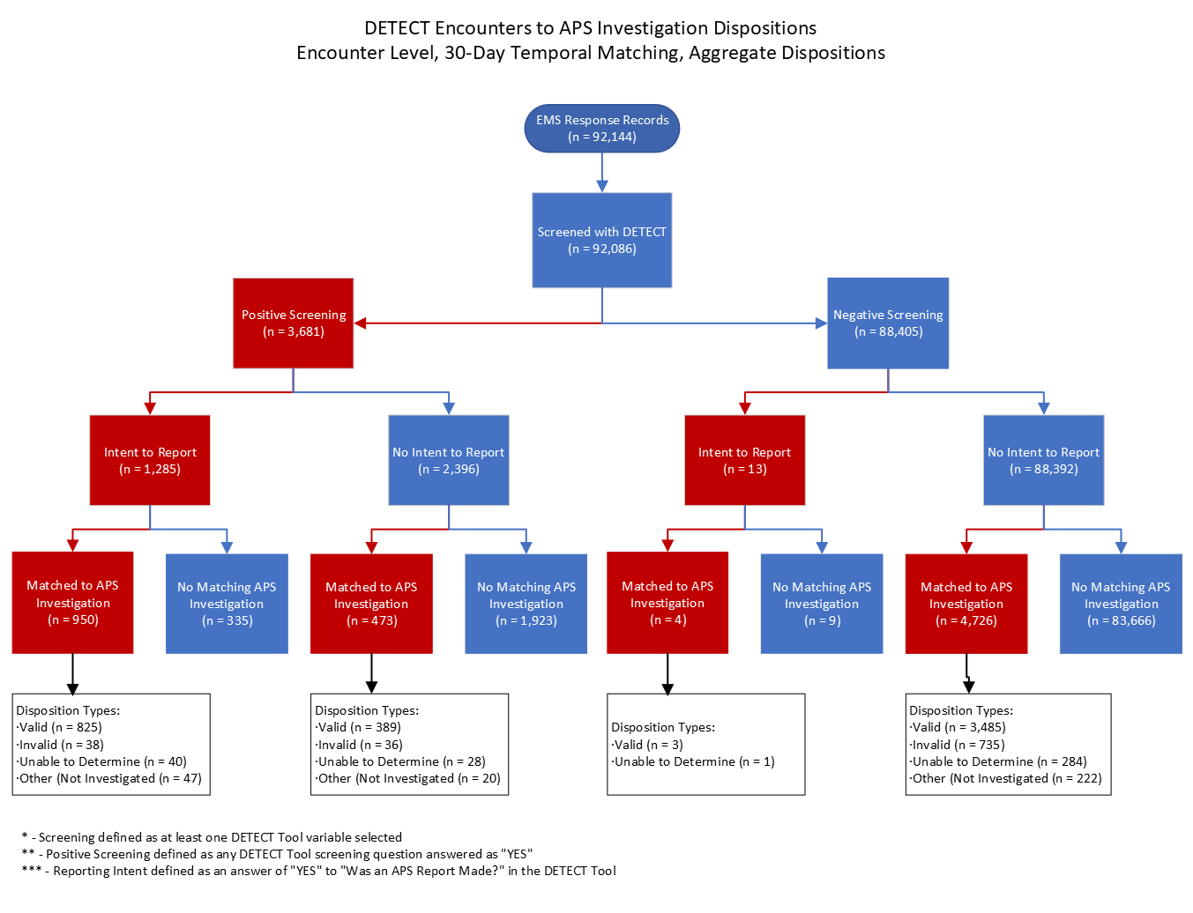

Discussion
Discussion Outline:
- Percentage of completed screenings & feasibility of completion
- Was the tool carried out as intended? Post validation rule- was there evidence of pencil whipping?
- If intent to report was indicated, then there was a high chance that there was a match to an APS investigation & there is a significant chance that negative screening, no intent to report did not match an APS investigation
- BUT, does that mean that there is no abuse occurring?

Conclusion

References
1. CDC. About Abuse of Older Persons. January 31, 2025. Accessed April 9, 2025. https://www.cdc.gov/elder-abuse/about/index.html
2. National Research Council (US) Panel to Review Risk and Prevalence of Elder Abuse and Neglect. Elder Mistreatment: Abuse, Neglect, and Exploitation in an Aging America. (Bonnie RJ, Wallace RB, eds.). National Academies Press (US); 2003. Accessed August 14, 2023. http://www.ncbi.nlm.nih.gov/books/NBK98802/
3. Connolly MT, Brandi B, Breckman R. The Elder Justice Roadmap: A Stakeholder Initaitive to Respond to an Emerging Health, Justice, Financial, and Social Crisis. US Department of Justice, National Center on Elder Abuse; 2014. Accessed August 14, 2023. https://www.google.com/url?sa=t&rct=j&q=&esrc=s&source=web&cd=&ved=2ahUKEwi6t8_oyOGAAxWmnGoFHVTLD8sQFnoECBAQAQ&url=https%3A%2F%2Fwww.justice.gov%2Ffile%2F852856%2Fdownload&usg=AOvVaw0q1gacI4F7_rliJ5iy2BOI&opi=89978449
4. Lachs MS, Pillemer KA. Elder Abuse. Campion E, ed. N Engl J Med. 2015;373(20):1947-1956. doi:10.1056/NEJMra1404688
5. Texas Department of Family and Protective Services. Texas Adult Protective Services Handbook: 3200 Allegations. April 2023. Accessed August 16, 2023. https://www.dfps.texas.gov/handbooks/APS/Files/APS_pg_3000.asp#APS_3200
6. Ramsey-Klawsnik H, Heisler C. Polyvictimization in later life. Victim Eldery Disabl. 2014;17(1):3-4,15-16.
7. Acierno R, Hernandez MA, Amstadter AB, et al. Prevalence and Correlates of Emotional, Physical, Sexual, and Financial Abuse and Potential Neglect in the United States: The National Elder Mistreatment Study. Am J Public Health. 2010;100(2):292-297. doi:10.2105/AJPH.2009.163089
8. Rosay AB, Mulford CF. Prevalence estimates and correlates of elder abuse in the United States: The National Intimate Partner and Sexual Violence Survey. J Elder Abuse Negl. 2017;29(1):1-14. doi:10.1080/08946566.2016.1249817
9. Cooper C, Selwood A, Blanchard M, Walker Z, Blizard R, Livingston G. Abuse of People with Dementia by Family Carers: Representative Cross Sectional Survey. BMJ. 2009;338(7694):583-586.
10. Wiglesworth A, Mosqueda L, Mulnard R, Liao S, Gibbs L, Fitzgerald W. Screening for Abuse and Neglect of People with Dementia. J Am Geriatr Soc. 2010;58(3):493-500. doi:10.1111/j.1532-5415.2010.02737.x
11. Pickering CEZ, Yefimova M, Maxwell C, Puga F, Sullivan T. Daily Context for Abusive and Neglectful Behavior in Family Caregiving for Dementia. The Gerontologist. 2020;60(3):483-493. doi:10.1093/geront/gnz110
12. Dong XQ. Elder Abuse: Systematic Review and Implications for Practice. J Am Geriatr Soc. 2015;63(6):1214-1238. doi:10.1111/jgs.13454
13. Dong X, Chen R, Simon MA. Elder Abuse And Dementia: A Review Of The Research And Health Policy. Health Aff (Millwood). 2014;33(4):642-649.
14. Lachs M, Berman J. Under the Radar: New York State Elder Abuse Prevalence Study. Lifespan of Greater Rochester, Inc; Weill Cornell Medical Center of Cornell University; & New York City Department for the Aging; 2011. Accessed August 14, 2023. https://www.google.com/url?sa=t&rct=j&q=&esrc=s&source=web&cd=&ved=2ahUKEwjJrrq17OGAAxWzl2oFHTp-ApkQFnoECBcQAQ&url=https%3A%2F%2Focfs.ny.gov%2Freports%2Faps%2FUnder-the-Radar-2011May12.pdf&usg=AOvVaw1SYwor0C74Tsr6V0jVZi94&opi=89978449
15. Acierno R, Hernandez-Tejada MA, Anetzberger GJ, Loew D, Muzzy W. The National Elder Mistreatment Study: An 8-year longitudinal study of outcomes. J Elder Abuse Negl. 2017;29(4):254-269. doi:10.1080/08946566.2017.1365031
16. Gibbs L, Mosqueda L. Elder abuse: a medical perspective. Aging Health. 2010;6(6):739-748. doi:10.2217/ahe.10.76
17. True Link Financial. The True Link Report on Elder Financial Abuse 2015. True Link Financial; 2015. Accessed August 13, 2023. http://documents.truelinkfinancial.com/True-Link-Report-On-Elder-Financial-Abuse-012815.pdf
18. Murphy K, Waa S, Jaffer H, Sauter A, Chan A. A Literature Review of Findings in Physical Elder Abuse. Can Assoc Radiol J. 2013;64(1):10-14. doi:10.1016/j.carj.2012.12.001
19. Dong X, Simon MA. Elder Abuse as a Risk Factor for Hospitalization in Older Persons. JAMA Intern Med. 2013;173(10):911-917. doi:10.1001/jamainternmed.2013.238
20. Dong X, Chen R, Chang ES, Simon M. Elder Abuse and Psychological Well-Being: A Systematic Review and Implications for Research and Policy - A Mini Review. Gerontology. 2012;59(2):132-142. doi:10.1159/000341652
21. Mouton CP, Rodabough RJ, Rovi SLD, Brzyski RG, Katerndahl DA. Psychosocial Effects of Physical and Verbal Abuse in Postmenopausal Women. Ann Fam Med. 2010;8(3):206-213. doi:10.1370/afm.1095
22. Acierno R, Watkins J, Hernandez-Tejada MA, et al. Mental Health Correlates of Financial Mistreatment in the National Elder Mistreatment Study Wave II. J Aging Health. 2019;31(7):1196-1211. doi:10.1177/0898264318767037
23. Berkowsky RW. Elder Mistreatment and Psychological Well-Being among Older Americans. Int J Environ Res Public Health. 2020;17(20):7525. doi:10.3390/ijerph17207525
24. Chokkanathan S, Natarajan A. Perceived Quality of Life following Elder Mistreatment in Rural India. J Gerontol Ser B. 2018;73(5):e69-e80. doi:10.1093/geronb/gbx043
25. Schofield MJ, Powers JR, Loxton D. Mortality and Disability Outcomes of Self-Reported Elder Abuse: A 12-Year Prospective Investigation. J Am Geriatr Soc. 2013;61(5):679-685. doi:10.1111/jgs.12212
26. Lachs MS, Williams CS, O’Brien S, Pillemer KA, Charlson ME. The Mortality of Elder Mistreatment. JAMA. 1998;280(5):428-432. doi:10.1001/jama.280.5.428
27. Mouton CP, Rodabough RJ, Rovi SLD, et al. Prevalence and 3-Year Incidence of Abuse Among Postmenopausal Women. Am J Public Health. 2004;94(4):605-612.
28. Shah MN, Bazarian JJ, Lerner EB, et al. The Epidemiology of Emergency Medical Services Use by Older Adults: An Analysis of the National Hospital Ambulatory Medical Care Survey. Acad Emerg Med. 2007;14(5):441-447. doi:10.1111/j.1553-2712.2007.tb01804.x
29. Cannell MB, Jetelina KK, Zavadsky M, Gonzalez JMR. Towards the development of a screening tool to enhance the detection of elder abuse and neglect by emergency medical technicians (EMTs): a qualitative study. BMC Emerg Med. 2016;16(1):19. doi:10.1186/s12873-016-0084-3
30. Rosen T, Lien C, Stern ME, et al. Emergency Medical Services Perspectives on Identifying and Reporting Victims of Elder Abuse, Neglect, and Self-Neglect. J Emerg Med. 2017;53(4):573-582. doi:10.1016/j.jemermed.2017.04.021
31. Fulmer T, Guadagno L, Bitondo dyer C, Connolly MT. Progress in Elder Abuse Screening and Assessment Instruments. J Am Geriatr Soc. 2004;52(2):297-304. doi:10.1111/j.1532-5415.2004.52074.x
32. Fulmer TT, Cahill VM. Assessing Elder Abuse: A Study. J Gerontol Nurs. 1984;10(12):16-20.
33. Rathbone-McCuan E. Elderly Victims of Family Violence and Neglect. Soc Casework. 1980;61(5):296-304. doi:10.1177/104438948006100505
34. Hwalek M, Others A. Assessing the Probability of Abuse of the Elderly.; 1984. Accessed August 17, 2023. https://eric.ed.gov/?id=ED257016
35. Yaffe MJ, Wolfson C, Lithwick M, Weiss D. Development and Validation of a Tool to Improve Physician Identification of Elder Abuse: The Elder Abuse Suspicion Index (EASI)©. J Elder Abuse Negl. 2008;20(3):276-300. doi:10.1080/08946560801973168
36. Reis M, Nahmiash D. Validation of the Indicators of Abuse (IOA) Screen. The Gerontologist. 1998;38(4):471-480. doi:10.1093/geront/38.4.471
37. Reis M, Nahmiash D. Validation of the Caregiver Abuse Screen (CASE). Can J Aging Rev Can Vieil. 1995;14(S2):45-60. doi:10.1017/S0714980800005584
38. Aravanis SC, Adelman RD, Breckman R, et al. Diagnostic and treatment guidelines on elder abuse and neglect. Arch Fam Med. 1993;2(4):371-388. doi:10.1001/archfami.2.4.371
39. Perel-Levin S. Discussing Screening for Elder Abuse at Primary Health Care Level by Silvia Perel-Levin. World Health Organization; 2008. Accessed August 16, 2023. https://apps.who.int/iris/handle/10665/43523
40. Cooper C, Manela M, Katona C, Livingston G. Screening for elder abuse in dementia in the LASER-AD study: prevalence, correlates and validation of instruments. Int J Geriatr Psychiatry. 2008;23(3):283-288. doi:10.1002/gps.1875
41. Sooryanarayana R, Choo WY, Hairi NN. A Review on the Prevalence and Measurement of Elder Abuse in the Community. Trauma Violence Abuse. 2013;14(4):316-325. doi:10.1177/1524838013495963
42. Cannell B, Gonzalez JMR, Livingston M, Jetelina KK, Burnett J, Weitlauf JC. Pilot testing the detection of elder abuse through emergency care technicians (DETECT) screening tool: results from the DETECT pilot project. J Elder Abuse Negl. 2019;31(2):129-145. doi:10.1080/08946566.2018.1564104
43. Service Area. MedStar Mobile Healthcare. Accessed July 20, 2023. https://www.medstar911.org/service-area/
44. Cannell B, Livingston M, Burnett J, Parayil M, Reingle Gonzalez JM. Evaluation of the Detection of Elder Mistreatment Through Emergency Care Technicians Project Screening Tool. JAMA Netw Open. 2020;3(5):e204099. doi:10.1001/jamanetworkopen.2020.4099
45. Texas Department of Family and Protective Services. Texas Adult protective services handbook, 4000 cases involving HHSC or other settings. 2022. Accessed July 20, 2023. https://www.dfps.texas.gov/handbooks/APS/Files/APS_pg_4000.asp#APS_4000
46. United States Census Bureau. Fort Worth city, Texas. United States Census Bureau Quick Facts. 2021. Accessed July 20, 2023. https://www.census.gov/quickfacts/fact/table/fortworthcitytexas/POP060210
47. Texas State Legislature. Investigations and Protective Services for Elderly Persons and Persons with Disabilities: Reports of Abuse, Neglect, or Exploitation: Immunities. Vol Chapter 48. Accessed July 20, 2023. https://statutes.capitol.texas.gov/Docs/HR/htm/HR.48.htm#48.051
48. Enamorado T, Fifield B, Imai K. fastLink: Fast Probabilistic Record Linkage with Missing Data. Published online April 29, 2020. Accessed July 20, 2023. https://cran.r-project.org/package=fastLink
49. R Core Team. R: A language and environment for statistical computing. Published online 2022. https://www.R-project.org
50. Wickham H. Ggplot2: Elegant Graphics for Data Analysis. Springer-Verlag New York; 2016. https://ggplot2.tidyverse.org
51. Pedersen TL. patchwork: The Composer of Plots. Published online 2024. https://github.com/thomasp85/patchwork, https://patchwork.data-imaginist.com

Notes & Comments
- Placeholder

Denominator is the total number of screenings (N = 92,085)
Denominator is the total number of completions of the item (column 2)
Denominator is the total number of “Yes” responses for the item (column 3)

